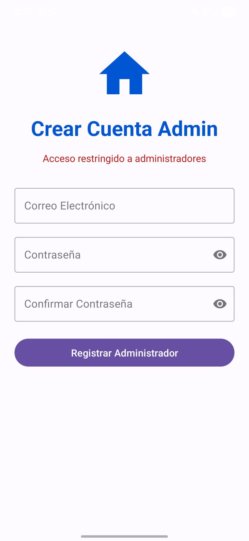
@Composable
fun CreateAdminAccountScreen() {
Column(
modifier = Modifier
.fillMaxSize()
.padding(24.dp)
.background(Color.White),
horizontalAlignment = Alignment.CenterHorizontally,
verticalArrangement = Arrangement.Top
) {
Spacer(modifier = Modifier.height(20.dp))

// Icono de inicio (Azul)
Icon(
imageVector = Icons.Default.Home,
contentDescription = null,
modifier = Modifier.size(100.dp),
tint = Color(0xFF0056D2)
)

// Títulos principales
Text(
text = "Crear Cuenta Admin",
fontSize = 32.sp,
fontWeight = FontWeight.Bold,
color = Color(0xFF0056D2)
)

Text(
text = "Acceso restringido a administradores",
fontSize = 14.sp,
color = Color.Red,
modifier = Modifier.padding(top = 8.dp)
)

Spacer(modifier = Modifier.height(40.dp))

// Campo Correo Electrónico
OutlinedTextField(
value = "", onValueChange = {},
label = { Text("Correo Electrónico") },
modifier = Modifier.fillMaxWidth(),
shape = RoundedCornerShape(8.dp)
)

Spacer(modifier = Modifier.height(16.dp))

// Campo Contraseña
OutlinedTextField(
value = "", onValueChange = {},
label = { Text("Contraseña") },
visualTransformation = PasswordVisualTransformation(),
trailingIcon = { Icon(Icons.Default.Visibility, null) },
modifier = Modifier.fillMaxWidth(),
shape = RoundedCornerShape(8.dp)
)

Spacer(modifier = Modifier.height(16.dp))

// Campo Confirmar Contraseña
OutlinedTextField(
value = "", onValueChange = {},
label = { Text("Confirmar Contraseña") },
visualTransformation = PasswordVisualTransformation(),
trailingIcon = { Icon(Icons.Default.Visibility, null) },
modifier = Modifier.fillMaxWidth(),
shape = RoundedCornerShape(8.dp)
)

Spacer(modifier = Modifier.height(32.dp))

// Botón Registrar (Morado redondeado)
Button(
onClick = { /* Lógica de registro */ },
modifier = Modifier
.fillMaxWidth()
.height(56.dp),
shape = RoundedCornerShape(28.dp), // Botón totalmente redondeado
colors = ButtonDefaults.buttonColors(containerColor = Color(0xFF6750A4))
) {
Text("Registrar Administrador", color = Color.White, fontSize = 16.sp)
}
}
}

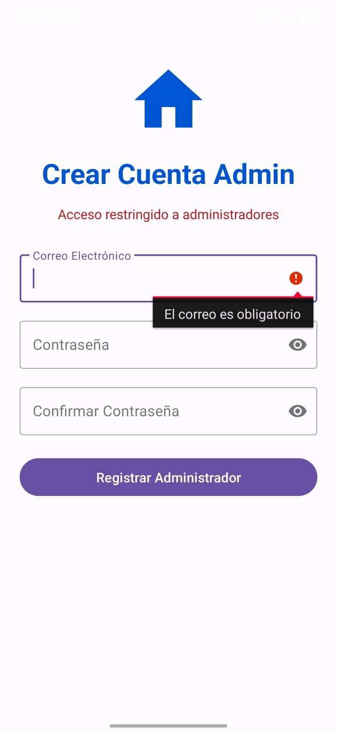
@Composable
fun AdminRegisterScreen() {

Column(
modifier = Modifier
.fillMaxSize()
.padding(24.dp)
.background(Color.White),
horizontalAlignment = Alignment.CenterHorizontally
) {
Spacer(modifier = Modifier.height(20.dp))

// Logo de la casa en azul (0xFF0056D2)
Icon(
imageVector = Icons.Default.Home,
contentDescription = null,
modifier = Modifier.size(100.dp),
tint = Color(0xFF0056D2)
)

// Título principal azul y negrita
Text(
text = "Crear Cuenta Admin",
fontSize = 32.sp,
fontWeight = FontWeight.Bold,
color = Color(0xFF0056D2)
)

// Texto de aviso en rojo
Text(
text = "Acceso restringido a administradores",
fontSize = 14.sp,
color = Color.Red,
modifier = Modifier.padding(top = 8.dp)
)

Spacer(modifier = Modifier.height(40.dp))

// Campo de Correo Electrónico
OutlinedTextField(
value = "", onValueChange = {},
label = { Text("Correo Electrónico") },
modifier = Modifier.fillMaxWidth(),
shape = RoundedCornerShape(8.dp)
)

Spacer(modifier = Modifier.height(16.dp))

// Campo de Contraseña con icono de ojo
OutlinedTextField(
value = "", onValueChange = {},
label = { Text("Contraseña") },
visualTransformation = PasswordVisualTransformation(), // Oculta el texto
trailingIcon = { Icon(Icons.Default.Visibility, null) },
modifier = Modifier.fillMaxWidth(),
shape = RoundedCornerShape(8.dp)
)

Spacer(modifier = Modifier.height(16.dp))

// Confirmar Contraseña
OutlinedTextField(
value = "", onValueChange = {},
label = { Text("Confirmar Contraseña") },
visualTransformation = PasswordVisualTransformation(),
trailingIcon = { Icon(Icons.Default.Visibility, null) },
modifier = Modifier.fillMaxWidth(),
shape = RoundedCornerShape(8.dp)
)

Spacer(modifier = Modifier.height(32.dp))

// Botón morado (0xFF6750A4) totalmente redondeado
Button(
onClick = { /* Acción de registro */ },
modifier = Modifier
.fillMaxWidth()
.height(56.dp),
shape = RoundedCornerShape(28.dp), // Esto hace el botón ovalado como en la imagen
colors = ButtonDefaults.buttonColors(containerColor = Color(0xFF6750A4))
) {
Text("Registrar Administrador", color = Color.White, fontSize = 16.sp)
}
}
}

